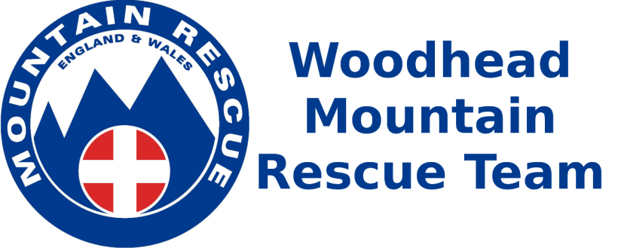
The Mountain Rescue Team will be visiting us to talk about survival equipment. Design your own piece of survival equipment to share with them!

