Name:

Class 5 Maths

What number is 1,000 less than 9,072?
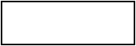
1 mark

Order the numbers starting with the largest.
Match each number with its order.
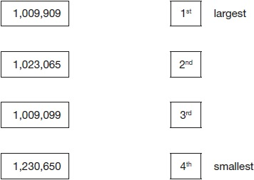
1 mark

3,576,219

Which digit is in the ten thousands place?
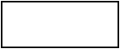
1 mark
Round 3,576,219 to the nearest million.
1 mark

Write these masses in order, starting with the lightest.
1.25 kg 0.99 kg 1.025 kg 0.009 kg
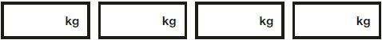
lightest
1 mark

The numbers in this sequence decrease by the same amount each time.
303,604 302,604 301,604 300,604 …
What is the next number in the sequence?
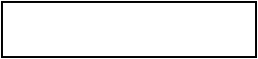
1 mark

Write these numbers in order of size, starting with the smallest.
1.9 0.96 1.253 0.328

smallest
1 mark

Ali puts these five numbers in their correct places on a number line.
511 499 502 555 455
Write the number closest to 500

1 mark
Write the number furthest from 500
1 mark

Circle two numbers that add together to equal 0.25
0.05 0.23 0.2 0.5
1 mark

Look at this number.
23,451.96
Write the digit that is in the hundreds place.
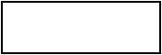
1 mark
Write the digit that is in the hundredths place.
1 mark

Write the number 53,148 in words.

___________________________________________________________________
1 mark

Write these numbers in order, starting with the smallest.

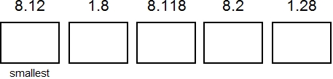
1 mark

There are 219 boys and 187 girls in a school.
What is the total number of children?

Write one of these signs in each empty box. You can use each sign more than once.
+ = –

15 | 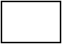 | 73 |  | 88
73 |  | 15 |  | 58

The numbers in this sequence increase by 14 each time.
Write the missing numbers.


John buys one toy car and one pack of stickers. He pays with a £10 note. How much change does John get?
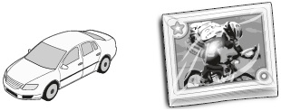
£1.49 £1.64

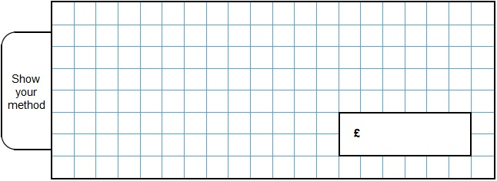
2 marks
The original price of this car is £8,999

What is the sale price of the car?
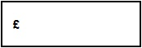

Write the three missing digits to make this addition correct.
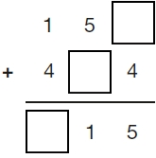
This table shows the number of people living in various towns in England.

Town | Population
Bedford | 82,448
Carlton | 48,493
Dover | 34,087
Formby | 24,478
Telford | 166,640

What is the total of the numbers of people living in Formby and in Telford?

Multiply by 2, and then add 3
In this sequence, the rule to get the next number is

Write the missing numbers.

2 marks

In this grid, there are four multiplications.
Write the three missing numbers.
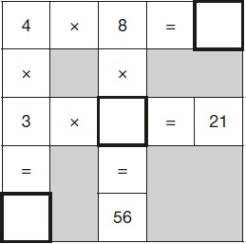
1 mark

Ken buys 3 large boxes and 2 small boxes of chocolates.
Each large box has 48 chocolates. Each small box has 24 chocolates.
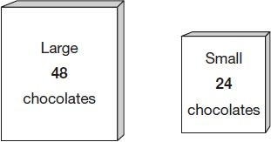
How many chocolates did Ken buy altogether?
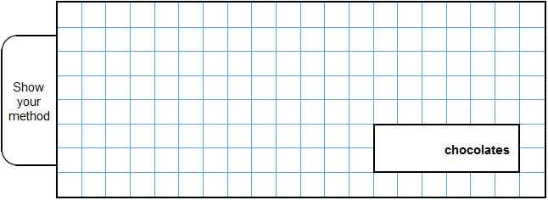
2 marks
A box contains trays of melons.

There are 15 melons in a tray.  There are 3 trays in a box. | 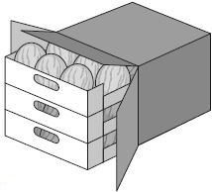
A supermarket sells 40 boxes of melons.
How many melons does the supermarket sell?
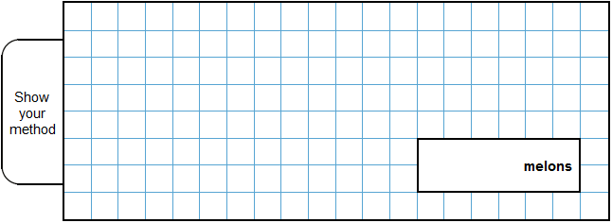
2 marks
Chen uses these digit cards.
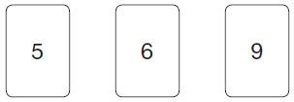
She makes a 2-digit number and a 1-digit number.
She multiplies them together.
Her answer is a multiple of 10
What could Chen’s multiplication be?
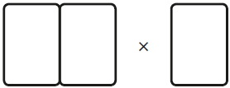 1 mark

A farmer is packing eggs.
Each box holds six eggs.
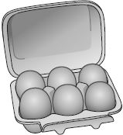
The farmer has 980 eggs to pack.
How many boxes can the farmer fill using 980 eggs?
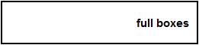
1 mark
How many eggs will be left over?
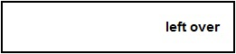
1 mark

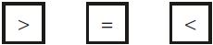
Write the correct symbol in each box to make the statements correct.
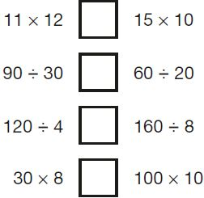
2 marks

3 pineapples cost the same as 2 mangoes.  One mango costs £1.35 | 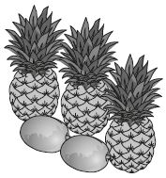
How much does one pineapple cost?
2 marks
Here are three symbols.
< > =
Write one symbol in each box to make the statements correct.
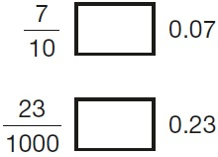
1 mark

Tick the fractions less than

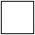
2 marks
These diagrams show three equivalent fractions.
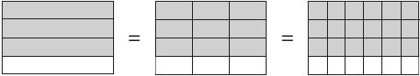

Write the missing values.
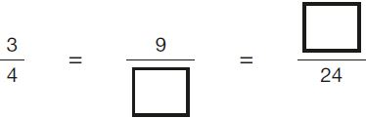
1 mark

Tick the two numbers that are equivalent to
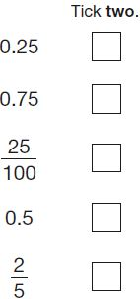
1 mark
Circle the improper fraction that is equivalent to
1 mark

Tick two shapes that have shaded.
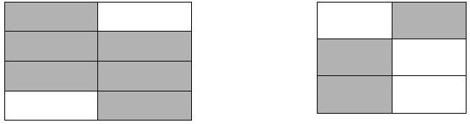
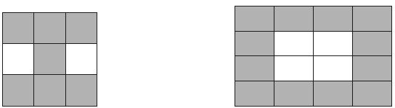

A book has 276 pages.
Amina has read of the book.
How many pages are left for Amina to read?
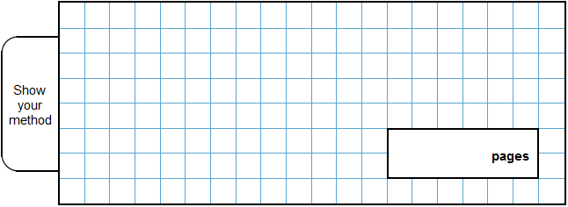
2 marks

Adam says,
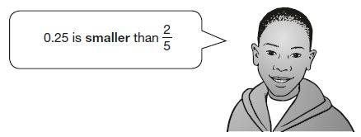
Explain why he is correct.


Here are three symbols.
< > =
Write one symbol in each box to make the statements correct.
1 mark

Write these numbers in order of size, starting with the smallest.
1.9 0.96 1.253 0.328
smallest
1 mark

Write these in order of size, starting with the smallest.
0.5 0.65

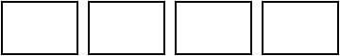
smallest
1 mark

Write these numbers in order, starting with the smallest.
0.78 0.607 5.6 0.098 4.003

smallest
1 mark

Write in the missing numbers.

Number | Rounded to the  nearest whole number
5.05
5.55
4.45
4.54
2 marks

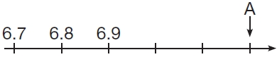
What number is marked at A?
1 mark

Two decimal numbers add together to equal 1
One of the numbers is 0.007
What is the other number?
1 mark

Circle the number that is closest to 20
19.95 20.1 19.09 20.09 20.201
1 mark

Join each fraction to the correct decimal card.
The first one has been done for you.



